**Duplicate emails:**

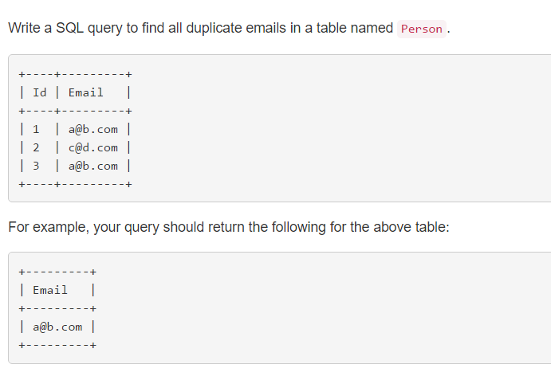

* Select Email from Person

Group by email

Having (count(Email) > 1);